**Turtle Programming Assignment #1**

Draw a 3 X 3 grid to the front and right of the turtle using only the functions moveForward() and turnLeft() as *efficiently* as possible. The turtle should end at its original location, facing its original direction. (Output should be exactly as below).

Note: You should **only** use functions moveForward() and and turnLeft() provided in the starter code.

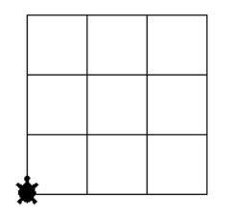

**Answer the following questions when you have finished your program.**

1. What do you think is meant by the word, “efficiently” in the problem?

2. Today we solved a problem with a limited set of commands (only 2). Give at least one reason why it's useful to learn how to solve and program solutions with a limited set of commands.

3. What was the most frustrating thing about this activity? If you could add one additional simple command, what would it be and why?